Hotfix/Update workflow: <http://www.processon.com/diagraming/5844e041e4b0d0d77bff01e7>

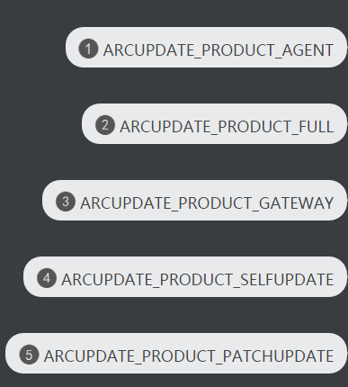

**APM_TYPE_D2D = 0;**

**APM_TYPE_CPM = 1;**

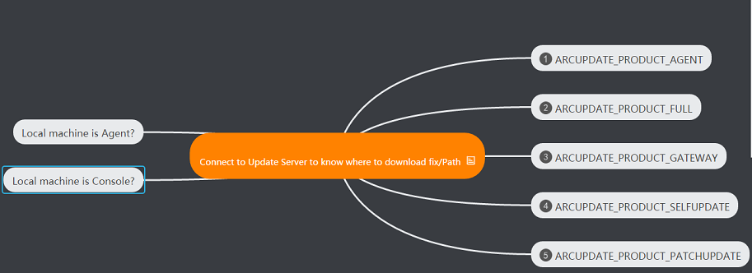

**For Agent:** How to download Hotfix/Update:

the current UDP works like this:

If current installed UDP Version is 16, we just check the patch from the fixed-location on the patch server, which means the patch folder on the server is hardcode like this:







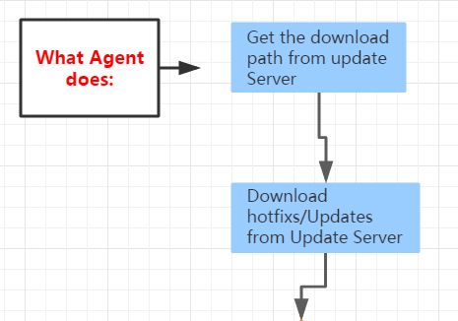

How to show the Hotfix/Update:

If current installed UDP Version **==** Hotfix/Update;

No need to do anything

else

Showing the warning message to tell the user: Please install the main version first before applying any Hotfix/updates

check the correct local main version and sub-version of UDP, like r6.0. xx

If current installed UDP Version **<** Hotfix/Update

(Notes: the main version must be the same, because we just download the Hotfix/Updates basing on the same main version)

No No

Yes

Showing the following below

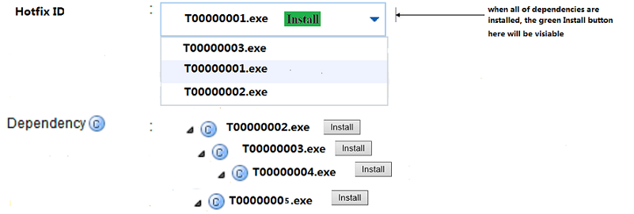

How to install:

Click  to install directly to the local agent machine

Configuration changed after installing certain hotfix/update









For Console: How to download Hotfix/Update **dwProd =1001**

the current UDP works like this:

If current installed UDP Version is 16, we just check the patch from the fixed-location on the patch server, which means the patch folder on the server is hardcode like this:







Put the Hotfix/Update to two different folders:



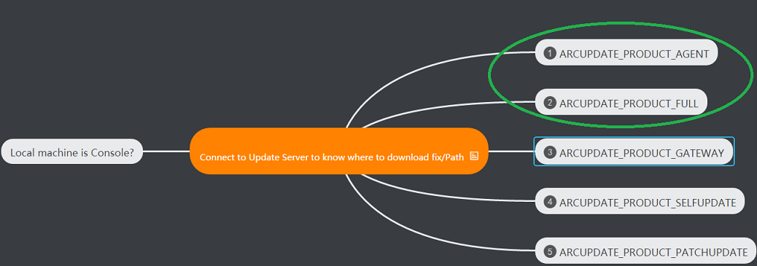

How to show the Hotfix/Update:

If current installed UDP Version **==** Hotfix/Update;

No need to do anything

else

Showing the warning message to tell the user: Please install the main version first before applying any Hotfix/updates

check the correct local main version and sub-version of UDP, like r6.0. xx

If current installed UDP Version **<** Hotfix/Update

(Notes: the main version must be the same, because we just download the Hotfix/Updates basing on the same main version)

No No

Yes

Showing the following below

 

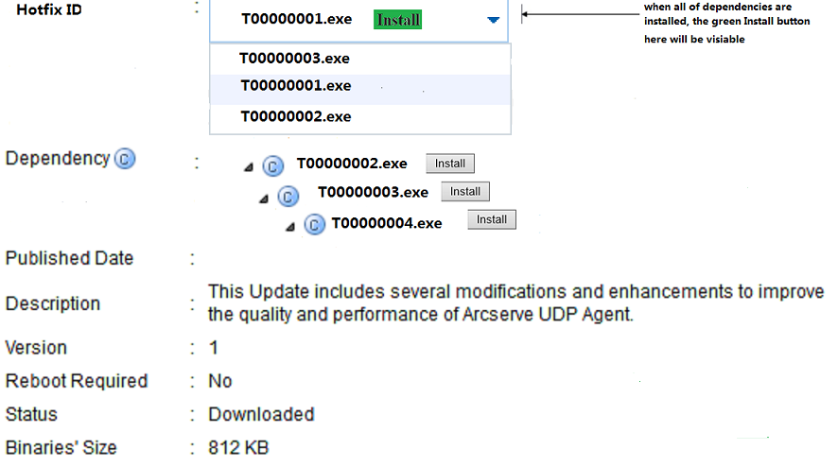

How to install:

Click  to install directly to the local agent machine

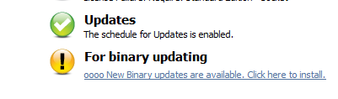

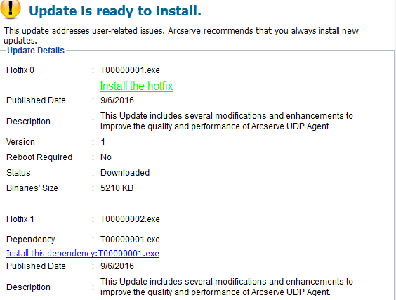

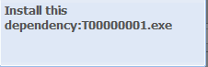

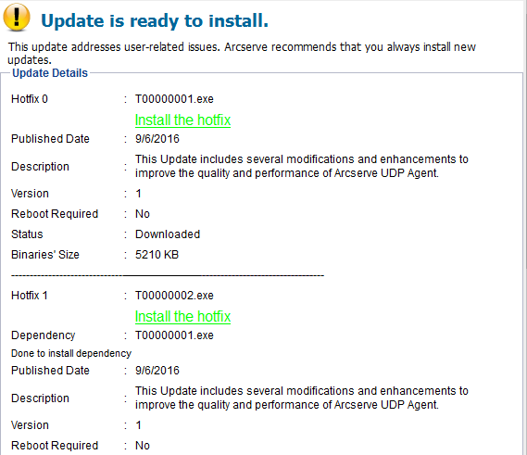

Console:



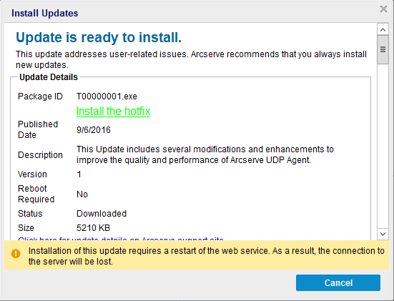

Source code: git clone [root@yanzh02-bldreq:/git/udp_bi_3720/UDP_3792.git](mailto:root@yanzh02-bldreq:/git/udp_bi_3720/UDP_3792.git)

Questions about how to deploy the patch files and how to manage it.

1. put binaries into another folder instead of under “C:\Program Files\Arcserve\Unified Data Protection\Update Manager\EngineUpdates”
2. refer to windows update server about how to install patch
3. check if main patch was installed, then ignore the current minor patch update
4. check which patch files was installed already in the current environment and which was not
5. submit a build request and we can get the update binaries
6. check the big version first and then check the small version
7. integrate patches into update1 or update2 ...

add:

1. recursive dependency
2. there is only one entry to check/download patch hotfix
3. how to show the relationship of big version and small version
4. asbu path manager
5. How to record the hotfix information
6. Hotfix list need to have version? Like 6.0.3752.1 hotfix version control
7. Status.xml need record which main version that is basing
8. Document record the relationship between with current auto-update and hotfix
9. Source control need to change to show or represent the hotfix or auto-update: different from any hotfix or auto-update
10. Change name from hotfix to patch
11. Draw picture to show the relationship between update and hotfix or main patch and update/hotfix
12. Critical issue will not show whether install or not, and will install backend
13. Update server will store the patch/hotfix information
14. Separated app from console to manage the patch/hotfix
15. Monday and Friday meeting to know how to start and what we need to do on the next step

Stage server: Pek-sin-inst Port: 80

Where the hotfix will be put: Single_Install\UDPUpdates\EngineUpdates\r6.0_Binary

Preparations for the environment to compile in Eclipse:

* Install Eclipse and firefox

\\wanhu08-w12r2\gwt_tools\Firefox24.0_9ht

how to fix the compiler error about "'DOMDocument60’: is not a member of 'MSXML2'and 'DOMDocument60’: undeclared"

Such kind of errors are related to the version of VS2015

1. copy the older msxml3.dll from the build machine which can compile the projects successfully into certain folder of the current compiling machine, for example: e:\document60_xml

2. run the cmdline below:

set path=%~dp0; %path%

start "" "C:\Program Files (x86) \Microsoft Visual Studio 12.0\Common7\IDE\devenv.exe"

3. copy ARCUpdate.dll, ARCUpdate.exe and UpdateBinaryJob.exe to the installation path of UDP (Build 3792.0)

4. add one-line value as <binary_onsource>Single_Install\UDPUpdates\EngineUpdates\r6.0_Binary</binary_onsource> to UpdateURL.xml

5.

修改类似这种目录下的xml文件；E:\UDP_3792\ARCserve\D2D\Server\Common\.settings\org.eclipse.wst.common.project.facet.core.xml

把<installed facet="jst.java" version="1.7"/>改成

<installed facet="jst.java" version="1.8"/>

In order to debug agent:

1.copy all of the files under C:\Program Files\Arcserve\Unified Data Protection\Engine\TOMCAT\webapps\WebServiceImpl\WEB-INF\wsdl to

E:\UDPMain\UDP_3792\ARCserve\D2D\Server\WebServiceContract\src\com\ca\arcflash\webservice

E:\UDPMain\UDP_3792\ARCserve\D2D\Server\WebServiceContract\bin\com\ca\arcflash\webservice

2. using the version of gwt is 2.6.1 (E:\UDPMain\UDP_3792\ARCserve\ExternalLib\gwt) not the default 2.6.0.

3.修改这个目录E:\UDP_3792\ARCserve\D2D\Server\WebUI\src\com\ca\arcflash\ui\client\login 下的LoginForm.java： LoginForm.java

ARCserve\ExternalLib\Tomcat8\apache-tomcat-8.0.28

4.

how to debug into FlashServiceImpl.java:

added "

-Xdebug

-Xrunjdwp:transport=dt_socket,address=8000,server=y,suspend=n-

Xrunjdwp:transport=dt_socket,address=8000,server=y,suspend=n" into the regedit Options:

[HKEY_LOCAL_MACHINE\SOFTWARE\Wow6432Node\Apache Software Foundation\Procrun 2.0\CASAD2DWebSvc\Parameters\Java]

-Dcatalina.base=C:\Program Files\Arcserve\Unified Data Protection\Engine\TOMCAT

-Dcatalina.home=C:\Program Files\Arcserve\Unified Data Protection\Engine\TOMCAT

-Djava.endorsed.dirs=C:\Program Files\Arcserve\Unified Data Protection\Engine\TOMCAT\endorsed

-Djava.io.tmpdir=C:\Program Files\Arcserve\Unified Data Protection\Engine\TOMCAT\temp

-Djava.util.logging.manager=org.apache.juli.ClassLoaderLogManager

-Djava.util.logging.config.file=C:\Program Files\Arcserve\Unified Data Protection\Engine\TOMCAT\conf

\logging.properties

-XX:+UseParallelOldGC

-XX:+HeapDumpOnOutOfMemoryError

-XX:MinHeapFreeRatio=10

-XX:MaxHeapFreeRatio=10

-Dlog4j.ignoreTCL=true

-Xdebug

-Xrunjdwp:transport=dt_socket,address=8000,server=y,suspend=n

5.

copy compiled FlashServiceImpl.wsdl into the installation path:

C:\Program Files\Arcserve\Unified Data Protection\Engine\TOMCAT\webapps\WebServiceImpl\WEB-INF\wsdl

6.

Since new added interface function are under FlashServiceImpl, so

after compiling of java, export the jar files flash-webservice-contract.jar and flash-webservice-impl.jar

into C:\Program Files\Arcserve\Unified Data Protection\Engine\TOMCAT\webapps\WebServiceImpl\WEB-INF\lib\

**Which files need to be replace if you want to debug**:

C:\Program Files\Arcserve\Unified Data Protection\Update Manager\ARCUpdate.dll

ARCUpdate.exe

UpdateURL.xml

New add file:

C:\Program Files\Arcserve\Unified Data Protection\Update Manager\UpdateBinaryJob.exe





For console update:

**Which files need to be replace if you want to debug**:

C:\Program Files\Arcserve\Unified Data Protection\Update Manager\ARCUpdate.dll

ARCUpdate.exe

UpdateURL.xml

New add file:

C:\Program Files\Arcserve\Unified Data Protection\Update Manager\UpdateBinaryJob.exe

C:\Program Files\Arcserve\Unified Data Protection\Management\BIN\

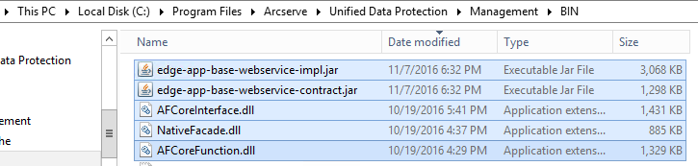

1. Run----debug configuration—VM Arguments

-Xmx1536m -Xmn384m -XX:MaxPermSize=384M -Xss2M "-Dcatalina.base=D:\Program Files\Arcserve\Unified Data Protection\Management\TOMCAT" "-Dcatalina.home=D:\Program Files\Arcserve\Unified Data Protection\Management\TOMCAT" "-Djava.io.tmpdir=D:\Program Files\Arcserve\Unified Data Protection\Management\TOMCAT\temp"

-Dcom.sun.management.jmxremote -Dcom.sun.management.jmxremote.port=9004 -Dcom.sun.management.jmxremote.authenticate=false -Dcom.sun.management.jmxremote.ssl=false

2.

C:\WorkAreas\ARCserve\Central\Server\EdgeAppBaseUI\resources下的文件需要都拷贝到C:\WorkAreas\ARCserve\Central\Server\EdgeAppCMUI\war

3.

把bin目录设到环境变量Path里试试

C:\Program Files\Arcserve\Unified Data Protection\Management\BIN

Folder: Central\Server\EdgeAppBaseServiceImpl\src\com\ca\arcserve\edge\app\base\webservice\gateway

通讯这块现在调试的时候我改了一行code

com.ca.arcserve.edge.app.base.webservice.gateway.EdgeGatewayBean 其中的**public** GatewayConnectInfo gatewayLogin( GatewayLoginInfo loginInfo )添加了一行

url = url.replace( ConsoleMessageServiceSettings.***PLACEHOLDER_BROKER_PORT***, String.*valueOf*(consoleApp.getMessageServiceSettings().getPort()) );

现在通讯也可以了，但是我看3792的代码库中也不需要这句。具体哪里出错了， 我还不太清楚，你需要问问pangbo和li neo。不过现在加上了 可以调试了，

Questions:

启动调试后 火狐总是停止加载，跟踪火狐控制台下面netWork 信息，发现总有一个获取*centralmanagementui.nocache.js的请求 使用了错误服务器端口。*

此文件应该是每次服务器启动时自动生成的，环境中这个文件一直没有被正确生成。

解决方法：手动删除 工程EdgeAppCMUI\war\ centralmanagementui文件夹，重启调试。发现此次正确生成了此文件。启动火狐调试，一切正常了。

How to debug hotfix from console side:

If you want use console build as gateway and eclipse as console ui,

Then follow the steps:

1 Remove management folder (C:\Program Files\Arcserve\Unified Data Protection\Management\TOMCAT\webapps\management) from console build.

2 Change <enableSSOLogin>true</enableSSOLogin> to <enableSSOLogin>false</enableSSOLogin> in C:\Program Files\Arcserve\Unified Data Protection\Management\Configuration\ SecurityServiceConfiguration.xml file

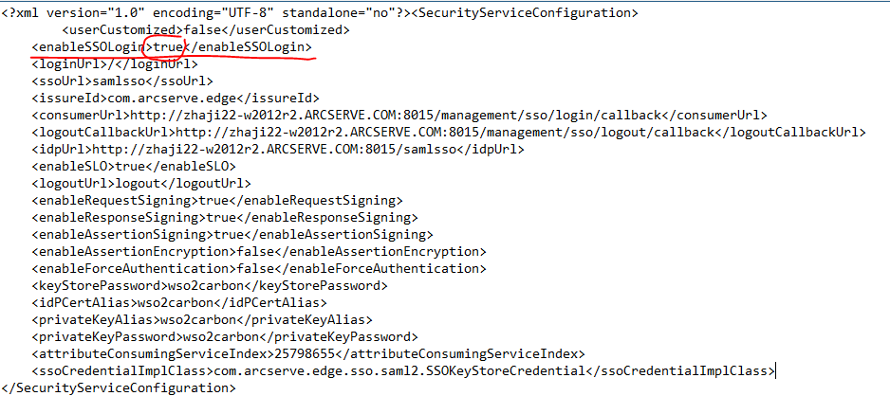

3 Change consolePort to your eclipse port and isDebugMode to true in in C:\Program Files\Arcserve\Unified Data Protection\Management\Configuration\ GatewayMessageService.xml file

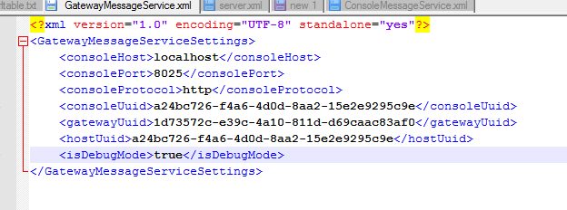

4 Please replace connectWebService method to the following code in EdgeGatewayBean.java

And copy the class file to C:\Program Files\Arcserve\Unified Data Protection\Management\TOMCAT\webapps\gateway\WEB-INF\

Like this:

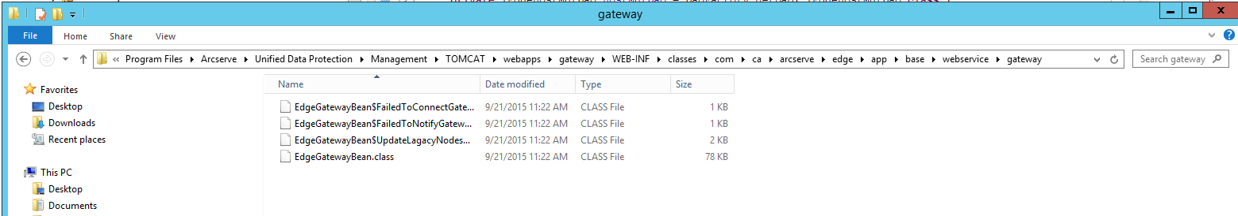

@SuppressWarnings( "deprecation" )

**private** **static** IEdgeGatewayService connectWebService(

            String hostname, **int** port, String protocol, String portName, String serviceName, String contextPath ) **throws** Exception

      {

            BaseWebServiceClientProxy webService = **null**;

            // connect web service

**try**

            {

                  String wsdlPath = "";

                  wsdlPath = String.*format*("services/%s?wsdl", serviceName );

                  // Set ServiceInfo

                  ServiceInfo serviceInfo = **new** ServiceInfo();

                  serviceInfo.setBindingType( ServiceInfoConstants.*SERVICE_BINDING_SOAP11* );

                  serviceInfo.setNamespace( ServiceInfoConstants.*SERVICE_EDGE_PROPER_NAMESPACE* );

                  serviceInfo.setPortName( portName );

                  serviceInfo.setServiceName( serviceName );

**if** (!protocol.endsWith( ":" ))

                        protocol = protocol + ":";

                  String wsdlURL = protocol + "//" + hostname + ":" + port

                        + "/" //CommonUtil.CENTRAL_MANAGER_CONTEXT_PATH

                        + wsdlPath;

                  serviceInfo.setWsdlURL( wsdlURL );

*logger*.info("wsdl url :" + wsdlURL);

                  // Set ServiceInfoConstants

                  String serviceID = ServiceInfoConstants.*SERVICE_ID_EDGE_PROPER*;

                  BaseWebServiceFactory serviceFactory = **new** BaseWebServiceFactory();

                  webService = serviceFactory.~~getWebService~~(

                        protocol, hostname, port, serviceID, serviceInfo, IEdgeGatewayService.**class** );

**if** (webService == **null**)

**throw** **new** Exception();

            }

**catch** (Exception e)

            {

**throw** e;

            }

**return** (IEdgeGatewayService) webService.getService();

      }

5 Restart console service

6 Start eclipse use another port not 8015 (eg: I use 8025, so GatewayMessageService.xml debug port is 8025)

